Game Design Document

Fill up the following document

1. Write the title of your project.

Pacman

1. What is the goal of the game?

Pacman needs to eat all the pills to win the game and if the ghosts eat the pacman it will lose 1 of its life

1. Write a brief story of your game.

You have to pack all the food and take it back to ur planets but ghosts are protecting their food from you. You have to be very careful playing this game you will have 3 lifes in 3 lifes you have to store all the food in your bag.

1. Which are the playing characters of this game?

* Playing characters are the ones who respond to the user based on the input from the user.
* Cars, monkeys, dinos, wizards, etc., are the playing characters in the game.

|  |  |  |
| --- | --- | --- |
| Number | Character Name | What can this character do? |
| 1 | PACMAN | He has to eat all the pills to win |
| 2 |  |  |
| 3 |  |  |
| 4 |  |  |
| 5 |  |  |
| 6 |  |  |
| 7 |  |  |
| 8 |  |  |

1. Which are the Non-Playing Characters of this game?

* Non-Playing characters are the ones that don't have an action or behavior when the user interacts with the game.
* Hurdles, stones, bananas, coins, etc., are non-playing characters in the game.

|  |  |  |
| --- | --- | --- |
| Number | Character Name | What can this character do? |
| 1 | Pills |  |
| 2 | Blue Ghost |  |
| 3 | Pink Ghost |  |
| 4 | Orange Ghost |  |
| 5 | Purple Ghost |  |
| 6 | Red Ghost |  |
| 7 | Cherry |  |
| 8 |  |  |

Draw your imagination of this game. What does this game look like?

* Draw the game either on your computer or on paper.
* Add images of the game scenes to show each of the playing and non-playing characters at least once.

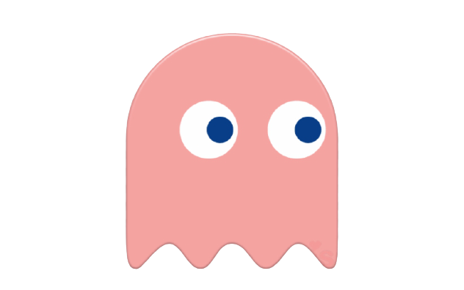

Here are the images of my game playing & non playing characters

How do you plan to make your game engaging?